

**AMRITA SCHOOL OF ENGINEERING**

**21AIE114**

**PRINCIPLES OF MEASUREMENTS AND SENSORS**

**BRANCH: CSE-AIE**

**SEMESTER-2**

**Title: TLW (Detecting the temperature, light and water level using sensors ).**



**UNDER THE GUIDANCE OF**: Mr. Nandi Vardhan Harlalli Rajendra

TEAM MEMBERS:

M Ramya Sree – BL.EN.U4AIE21072

Mettu Siddhartha- BL.EN.U4AIE21080

Poli Vamsi Vardhan Reddy – BL.EN.U4AIE21101

**ABSTRACT**

Now a day’s water is becoming very precious due to scarcity in obtaining clean water for domestic purpose including irrigation. In order to optimize the use of water, mechanism to develop water conversation is the need of the hour. Also, automation in agricultural systems is a necessity to optimize water usage, reduce water wastage, and to implement modern technology in agriculture systems. This system we used acts as a novel device which senses the moisture content in the soil, and with suitable mechanism allows water to be irrigated depending on the moisture content of the soil. This allows flow of water or stoppage of water to the plants by using an automated irrigation system. The system consists of an Arduino board, which is the micro controller which activates the motor and sends an alert sms before turning the motor on.

**TABLE OF CONTENTS**

|  |  |  |
| --- | --- | --- |
| S. No. | Contents | Pg. No. |
| 1 | Introduction | 4 |
| 2 | Working Principle | 5 |
| 3 | Components | 6 |
| 4 | Working Setup | 7 |
| 5 | Circuit Diagram | 14 |
| 6 | Result | 15 |
| 7 | Hardware Implementation | 18 |
| 8 | Code implementation | 20 |
| 9 | Future Scope & Conclusion | 26 |

**INTRODUCTION**

Agriculture plays an important role in the life of a Gross Domestic Product of every country. It is the backbone of economy of every country. Many problems have been found in Agriculture Sector. As the most serious problem is the shortage of water resources for the present as well as for future generation. It is necessary to adopt some smart techniques to preserve the water. The most highlighted feature of this project is how smartly and automatically control the water supply and maintains the water level to the agriculture fields according to the need. For this, sensors used are IR sensor, Temperature sensor, Ultrasonic sensor and Photo resistive sensor all these sensors are interface with Arduino UNO R3.

Every year irrigation requires more water consumption than rainfall, which will lead to a critical problem of water resources for the future generation. It is also difficult for farmers to find ways which need less water to grow crops.

This Project enables us to adopt the strategies to monitor the usage of water resources in agriculture fields as well as water level in the fields. The IR sensor checks the moisture level of the soil and send signals to Arduino. Arduino takes the decision of whether to switch-on or switch-off the water motor. Using such techniques, the wastage of water in agriculture can be stopped. Ultrasonic sensor detects the water level in the field.

**WORKING PRINCIPLE**

In this Proposed System, Temperature, Ultrasonic, IR and photo resistive sensors are connected to the input pins of Arduino Uno R3 microcontroller board. The Analog values produced from the sensors are converted to a digital output value by the Arduino Uno R3 microcontroller. The sensed values are displayed LCD. The water motor gets switch-off/on automatically based on the sensed value with respect to an already fixed threshold value, even ultrasonic sensor detects the level of water, based on the level of water LED blinks which are connected to Ultrasonic sensor and Arduino. Coming to the photo resistive sensor it detects the presence of light and turns off the Led and vice versa.

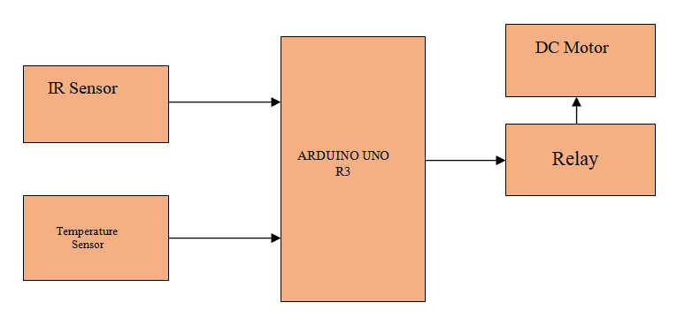

**COMPONENTS**

* Arduino UNO R3
* Breadboards
* Temperature Sensor
* Ultrasonic Sensor
* Infrared Sensor
* Photo resistive Sensor
* Relay SPDT
* LED’S
* Resistors
* Jumper Wires
* 9V Battery
* DC Motor
* 16x2 LCD Display

**WORKING SETUP**

**ARDUINO UNO:**

The **Arduino UNO R3**is frequently used[**microcontroller board**](https://www.elprocus.com/avr-atmega8-microcontroller-architecture-applications/) in the family of an Arduino. This is the latest third version of an Arduino board and released in the year 2011. The main advantage of this board is if we make a mistake, we can change the microcontroller on the board. The main features of this board mainly include, it is available in DIP (dual-inline-package), detachable and ATmega328 microcontroller. The programming of this board can easily be loaded by using an Arduino computer program. This board has huge support from the Arduino community, which will make a very simple way to start working in embedded electronics, and many more applications.

**Arduino UNO R3 specifications:**

The **A**rduino Uno R3 board includes the following specifications.

* It is an ATmega328P based Microcontroller
* The Operating Voltage of the Arduino is 5V
* The recommended input voltage ranges from 7V to 12V
* The i/p voltage (limit) is 6V to 20V
* Digital input and output pins-14
* Digital input & output pins (PWM)-6
* Analog i/p pins are 6
* DC Current for each I/O Pin is 20 mA
* DC Current used for 3.3V Pin is 50 mA
* Flash Memory -32 KB, and 0.5 KB memory is used by the boot loader
* SRAM is 2 KB
* EEPROM is 1 KB
* The speed of the CLK is 16 MHz
* In Built LED
* Length and width of the Arduino are 68.6 mm X 53.4 mm
* The weight of the Arduino board is 25 g

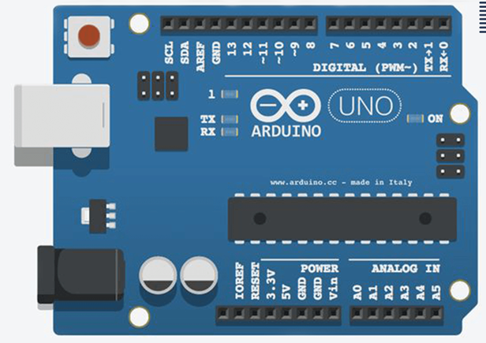

**Temperature Sensor:**

A temperature sensor is a device used to measure temperature. This can be air temperature, liquid temperature or the temperature of solid matter. There are different types of temperature sensors available and they each use different technologies and principles to take the temperature measurement. LM35 is a temperature measuring device having an analogue output voltage proportional to the temperature. It provides output voltage in Centigrade (Celsius). It does not require any external calibration circuitry. The sensitivity of LM35 is 10 mV/degree Celsius. As temperature increases, output voltage also increases.

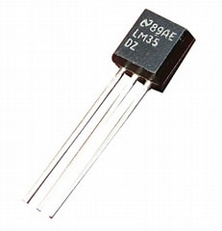

**Ultrasonic Sensor:**

Ultrasonic Sensor HC-SR04 is a sensor that can measure distance. It emits an ultrasound at 40,000 Hz (40kHz) which travels through the air and if there is an object or obstacle on its path it will bounce back to the module. Considering the travel time and the speed of the sound you can calculate the distance.The operation is not affected by sunlight or black material, although acoustically, soft materials like cloth can be difficult to detect. It comes complete with ultrasonic transmitter and receiver module.The configuration pin of HC-SR04 is VCC (1), TRIG (2), ECHO (3), and GND (4). The supply voltage of VCC is +5V and you can attach TRIG and ECHO pin to any Digital I/O in your Arduino Board.

**Technical Specifications:**

* Power Supply − +5V DC
* Quiescent Current − <2mA
* Working Current − 15mA
* Effectual Angle − <15°
* Ranging Distance − 2cm – 400 cm/1″ – 13ft
* Resolution − 0.3 cm
* Measuring Angle − 30 degree

**Infrared Sensor:**

An infrared sensor is an electronic device, that emits in order to sense some aspects of the surroundings. An IR sensor can measure the heat of an object.The **working of the IR sensor module** is very simple, it consists of two main components: the first is the IR transmitter section and the second is the IR receiver section. In the transmitter section, **IR led** is used and in the receiver section, a **photodiode** is used to receive infrared signal and after some signal processing and conditioning, you will get the output.

The IR sensor has a 3-pin connector. The connections are as follows:

1. VCC is the power supply pin for the IR sensor which we connect to the 5V pin on the Arduino.
2. OUT pin is a 5V TTL logic output.
3. GND Should be connected to the ground of the Arduino.

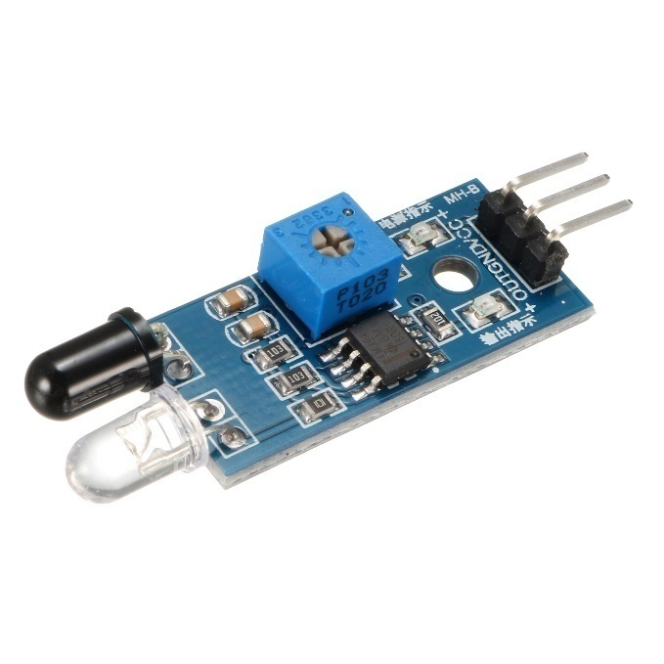

**Photo resistive Sensor:**

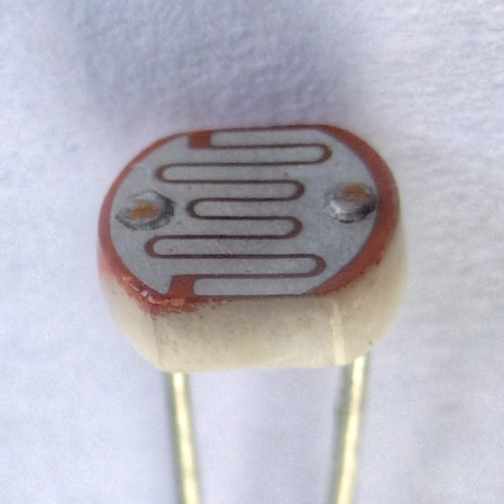

A photoresistor (also known as a Photocell, or light-dependent resistor, LDR, or photo-conductive cell) is a passive component that decreases resistance with respect to receiving luminosity (light) on the component's sensitive surface. The resistance of a photoresistor decreases with increase in incident light intensity; in other words, it exhibits photoconductivity. A photoresistor can be applied in light-sensitive detector circuits and light-activated and dark-activated switching circuits acting as a resistance semiconductor.

**Relay SPDT:**

[Relay](https://circuitdigest.com/article/relay-working-types-operation-applications) is an electromagnetic switch, which is controlled by small current, and used to switch ON and OFF relatively much larger current. It means by applying small current we can switch ON the relay which allows much larger current to flow. A relay is a good example of controlling the AC (alternate current) devices, using a much smaller DC current.**Single Pole Double Throw (SPDT) Relay is** commonly used Relay , it has five terminals.

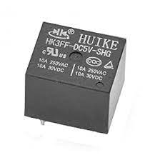

**Resistors:**

A resistor is an electrical component that limits or regulates the flow of electrical current in an electronic circuit. It is used because to lower the flow of current, divide voltages, block transmission signals, and bias active elements.

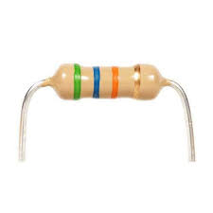

**NPN TRANSISTOR(BJT):**

The NPN transistor is designed to pass electrons from the emitter to the collector. The emitter emits electrons into the base, which controls the number of electrons the emitter emits.

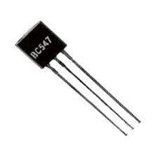

**9V Battery Source:**

Used as a Power Source to supply a steady 9V to the system.

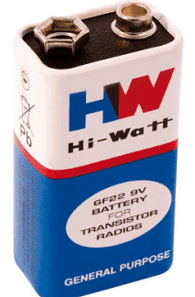

**DC Motor:**

A Direct Current motor is the most common type of motor. DC motors normally have just two leads, one positive and one negative. If you connect these two leads directly to a battery, the motor will rotate.If you switch the leads, the motor will rotate in the opposite direction.

Take the following precautions while making the connections.

* First, make sure that the transistor is connected in the right way. The flat side of the transistor should face the Arduino board.
* Second, the striped end of the diode should be towards the +5V power line according to the arrangement.

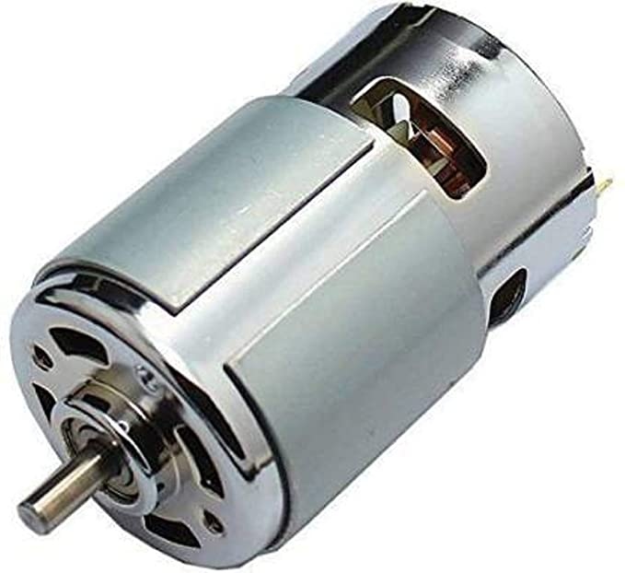

**CIRCUIT DIAGRAM**

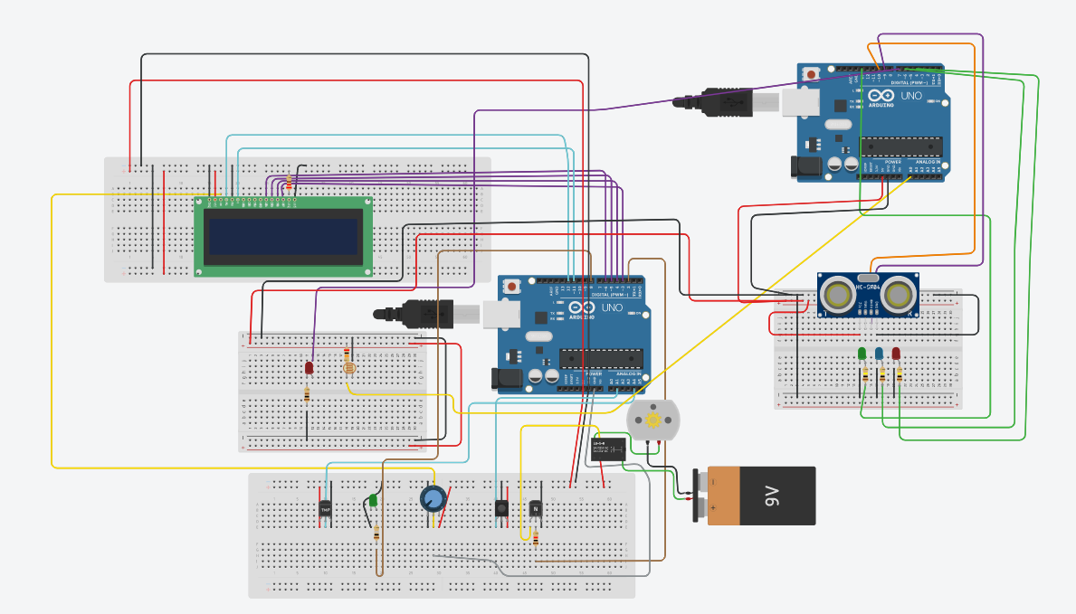

**RESULT**

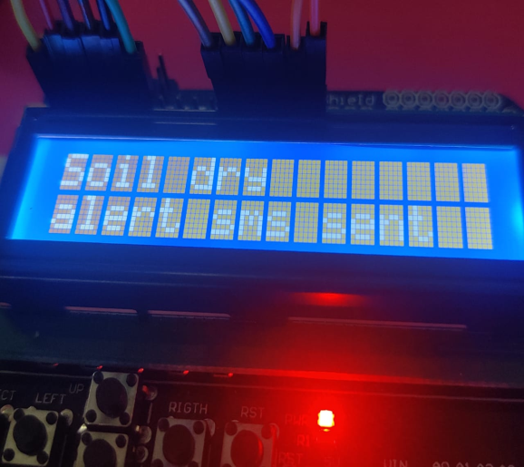 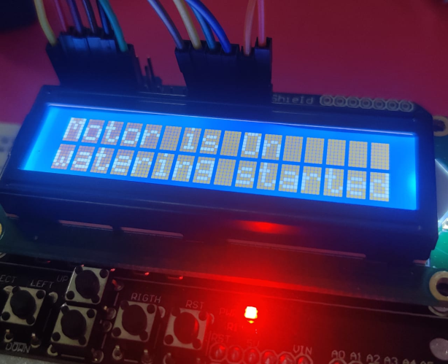

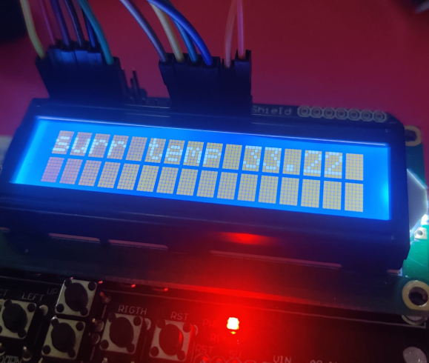 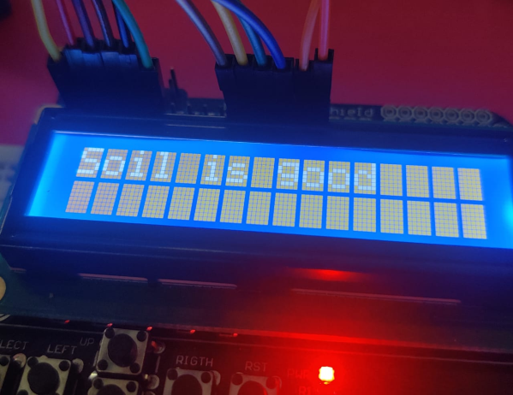

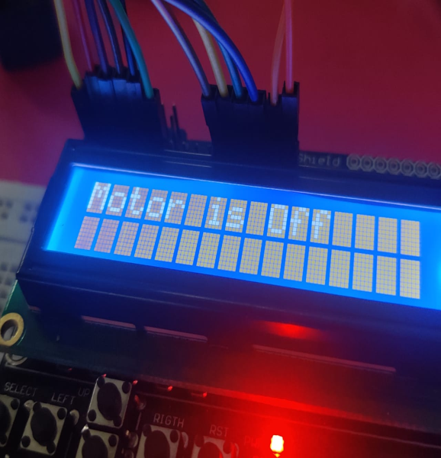 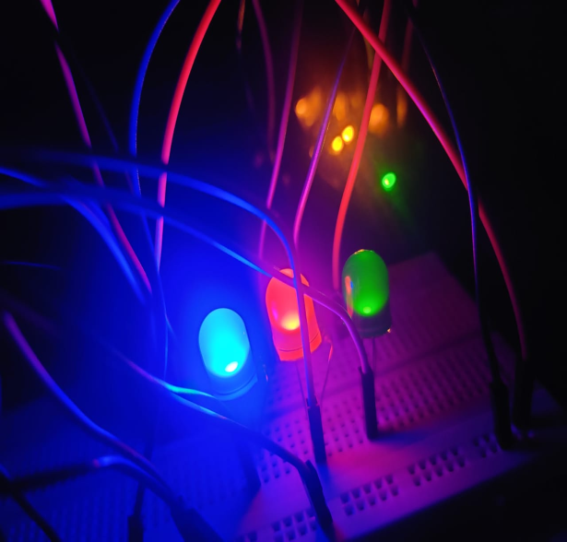

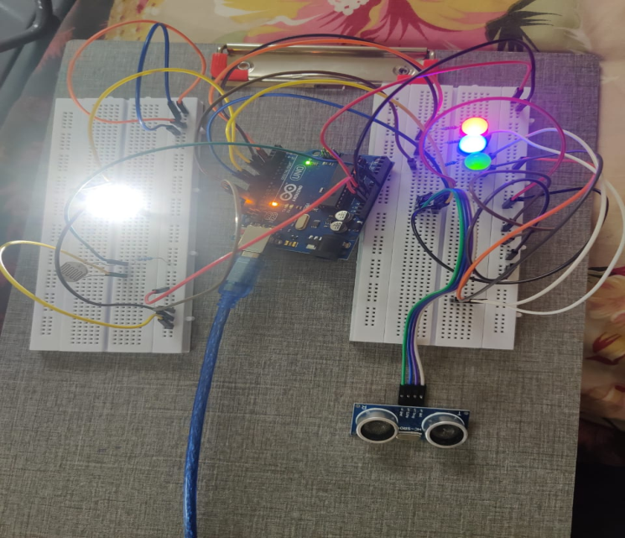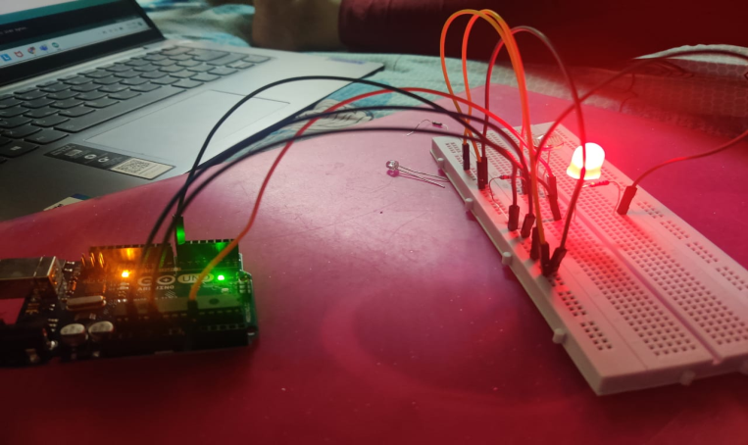

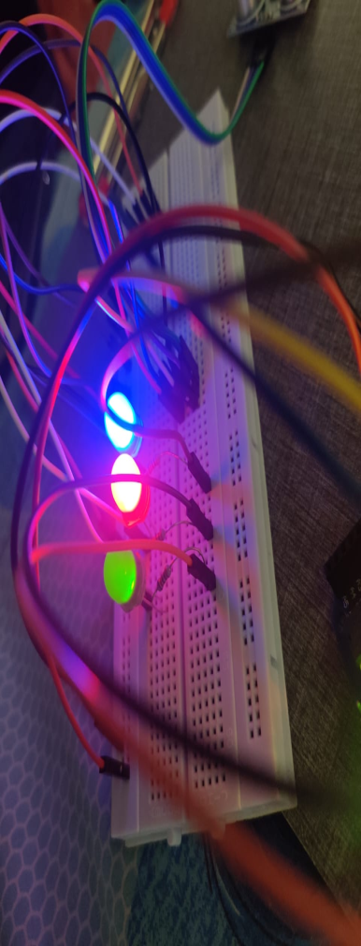

**Serial monitor:**

* **Ultra sonic sensor distance measurement:**

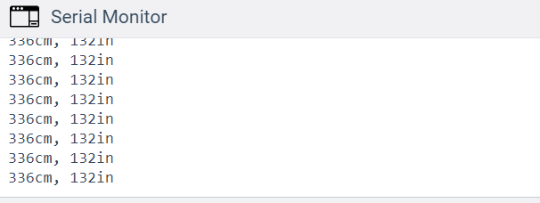

* **Current Temperature and soil moisture:**

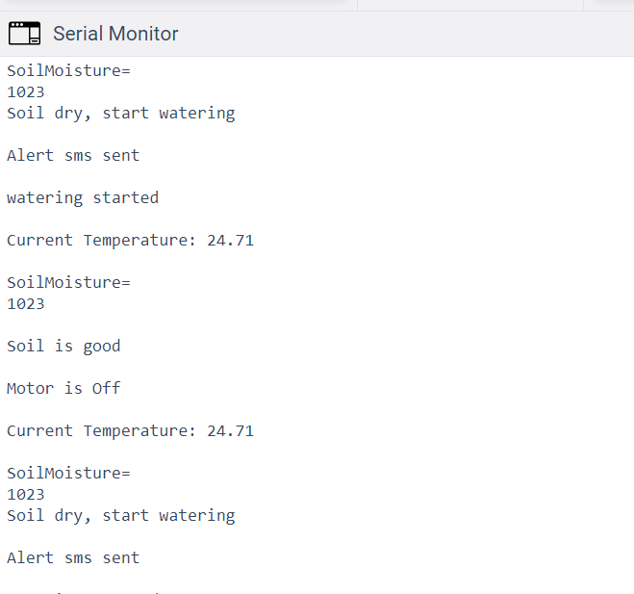

**HARDWARE IMPLEMENTATION**

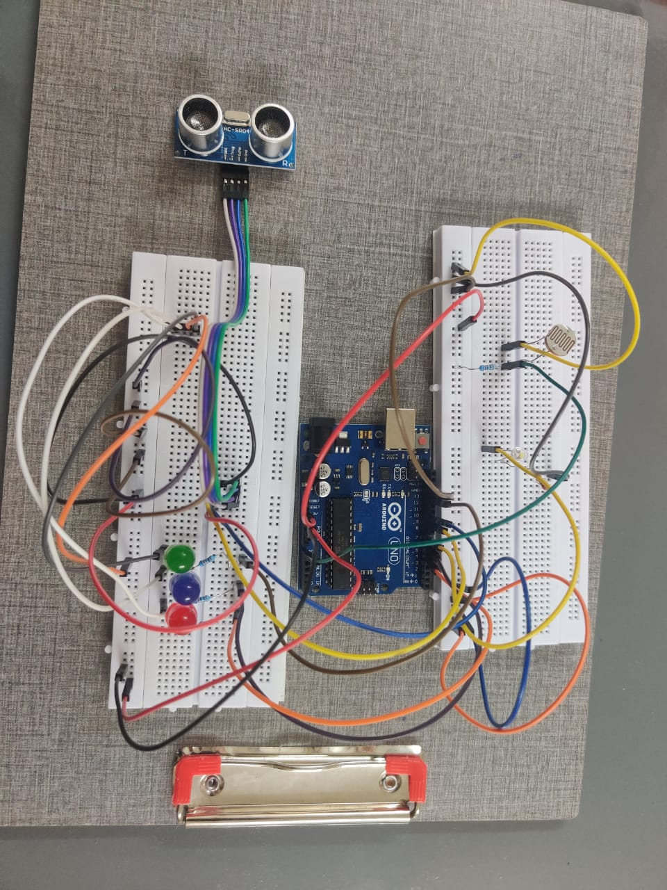

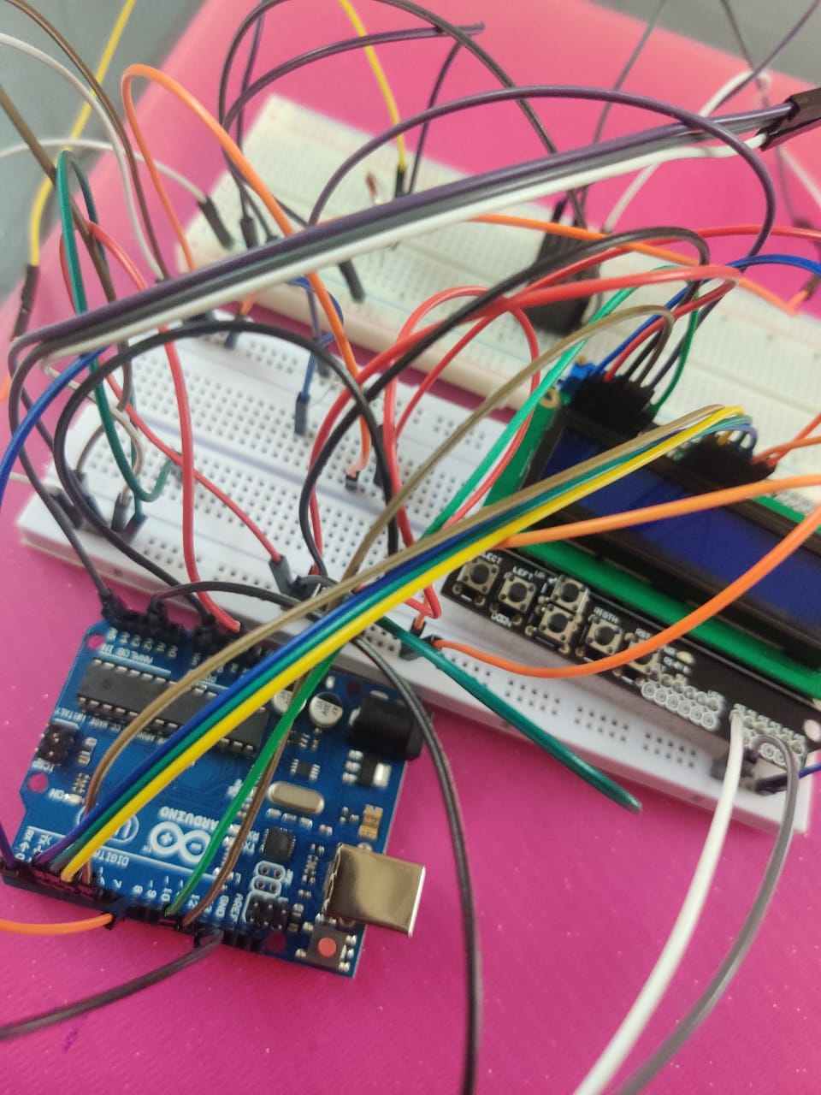

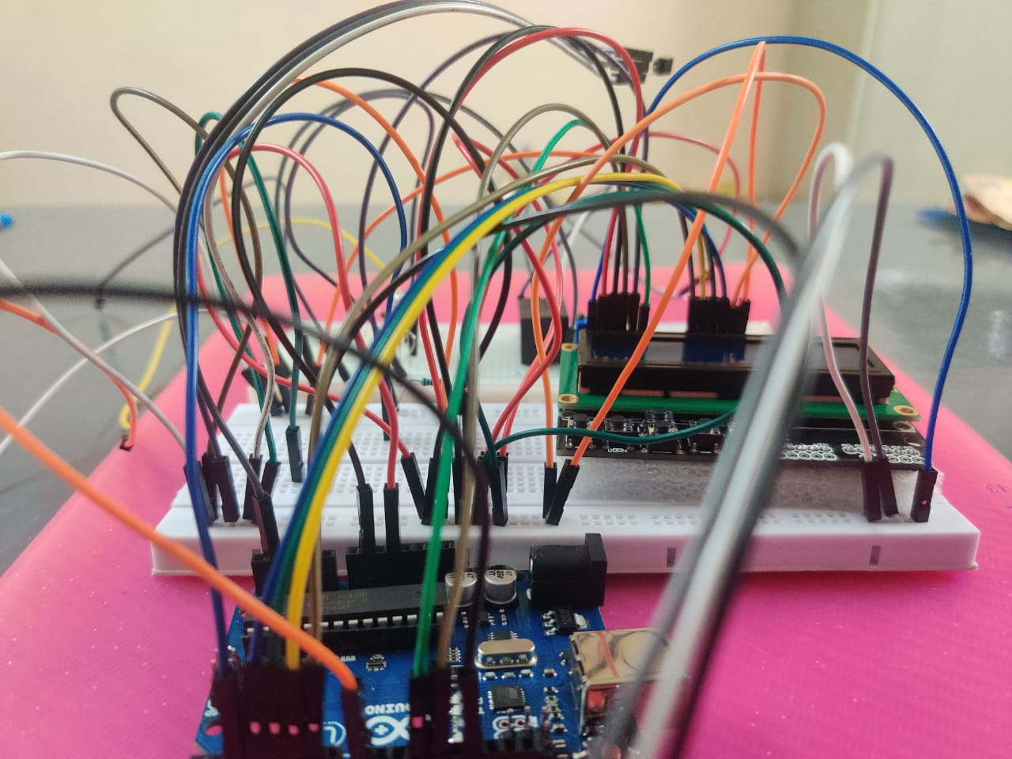

**CODE**

1st Arduino Board

#include <SoftwareSerial.h>

#include <LiquidCrystal.h>

#define WATERPIN 2

#define SENSOR A1

#define MAXDRYNESS 500

#define WATERPOSTDELAY 1000

int ch=0;

double temp;

int sensorInput;

LiquidCrystallcd(12, 11, 6, 5, 4, 3);

int distanceThreshold = 0;

int cm = 0;

int inches = 0;

long readUltrasonicDistance(int triggerPin, int echoPin)

{

pinMode(triggerPin, OUTPUT); // Clear the trigger

digitalWrite(triggerPin, LOW);

delayMicroseconds(2);

// Sets the trigger pin to HIGH state for 10 microseconds

digitalWrite(triggerPin, HIGH);

delayMicroseconds(10);

digitalWrite(triggerPin, LOW);

pinMode(echoPin, INPUT);

// Reads the echo pin, and returns the sound wave travel time in microseconds

return pulseIn(echoPin, HIGH);

}

void setup()

{

digitalWrite(WATERPIN, LOW);

pinMode(WATERPIN, OUTPUT);

Serial.begin(9600);

lcd.begin(16,2);

}

void loop() {

Soil_Moisture();

sensorInput = analogRead(A4);

temp = (double)sensorInput / 1024;

temp = temp * 5;

temp = temp - 0.5;

temp = temp * 100;

Serial.print("Current Temperature: ");

lcd.clear();

Serial.println(temp);

lcd.print("surr temp ");

lcd.print(temp);

delay(2000);

lcd.setCursor(0,1);

lcd.clear();

//delay(100);

}

void Soil_Moisture()

{

int SensorValue = analogRead(SENSOR);

Serial.print("\nSoilMoisture=\n");

Serial.print(SensorValue);

Serial.print("\n");

if(ch%2==0) //SensorValue>= MAXDRYNESS

{

Serial.println("Soil dry, start watering\n");

lcd.clear();

lcd.print("Soil dry");

lcd.setCursor(0,1);

lcd.print("alert sms sent");

Serial.println("Alert sms sent\n");

delay(2000);

lcd.clear();

lcd.print("Motor is On");

lcd.setCursor(0,1);

lcd.print("watering started");

Serial.println("watering started\n");

digitalWrite(8, HIGH);

digitalWrite(2, HIGH);

delay(8000);

digitalWrite(WATERPIN, LOW);

ch++;

lcd.clear();

}

else //SensorValue< MAXDRYNESS

{

Serial.println("\nSoil is good\n");

Serial.println("Motor is Off\n");

lcd.print("Soil is good");

delay(3000);

lcd.clear();

lcd.print("Motor is Off");

delay(3000);

lcd.clear();

digitalWrite(8,LOW);

delay(WATERPOSTDELAY);

ch++;

}

delay(2000);

}

Water Level Indicator Code

#definepinLed 7

#definepinFoto A0

int distanceThreshold = 0;

int cm = 0;

int inches = 0;

long readUltrasonicDistance(int triggerPin, int echoPin)

{

pinMode(triggerPin, OUTPUT); // Clear the trigger

digitalWrite(triggerPin, LOW);

delayMicroseconds(2);

// Sets the trigger pin to HIGH state for 10 microseconds

digitalWrite(triggerPin, HIGH);

delayMicroseconds(10);

digitalWrite(triggerPin, LOW);

pinMode(echoPin, INPUT);

// Reads the echo pin, and returns the sound wave travel time in microseconds

return pulseIn(echoPin, HIGH);

}

void setup()

{

Serial.begin(9600);

pinMode(pinLed, OUTPUT);

pinMode(pinFoto, INPUT);

pinMode(13, OUTPUT);

pinMode(6, OUTPUT);

pinMode(4, OUTPUT);

}

void loop()

{

analogWrite(pinLed,(analogRead(pinFoto)/4));

delay( 100 );

// set threshold distance to activate LEDs

distanceThreshold = 350;

// measure the ping time in cm

cm = 0.01723 * readUltrasonicDistance(10, 9);

// convert to inches by dividing by 2.54

inches = (cm / 2.54);

Serial.print(cm);

Serial.print("cm, ");

Serial.print(inches);

Serial.println("in");

if (cm >distanceThreshold) {

digitalWrite(13, LOW);

digitalWrite(6, LOW);

digitalWrite(4, LOW);

}

if (cm <= distanceThreshold&& cm >distanceThreshold - 100) {

digitalWrite(13, HIGH);

digitalWrite(6, LOW);

digitalWrite(4, LOW);

}

if (cm <= distanceThreshold - 100 && cm >distanceThreshold - 250) {

digitalWrite(13, HIGH);

digitalWrite(6, HIGH);

digitalWrite(4, LOW);

}

if (cm <= distanceThreshold - 250 && cm >distanceThreshold - 350) {

digitalWrite(13, HIGH);

digitalWrite(6, HIGH);

digitalWrite(4, HIGH);

}

if (cm <= distanceThreshold - 350) {

digitalWrite(13, HIGH);

digitalWrite(6, HIGH);

digitalWrite(4, HIGH);

}

//delay(100);

}

**FUTURE SCOPE**

**&**

**CONCLUSION**

This project is found to be cost-effective for enhancing the techniques to preserve water resources and to optimize them for agriculture production. This system helps the farmer by working automatically and smartly. With help of multiple sensors. This system requires less maintenance so it is easily affordable by all farmers. This system helps to reduce water consumption and also helps to keep an eye on the water level in the field. With using this system the crop production increases to a great extent. As per future perspective, this system can be the more intelligent system which predicts user actions, nutrient level of the plants, time to harvest, etc. With using Machine Learning algorithms more advancements can be done in the future which will help farmer a lot and water consumption can also be reduced in agriculture. We can also use an GSM module to send the alert message to our mobile which alerts us about the motor status(turned on/off).